**VideoConversation page content**

www.firebrandinnovations.com/videoconversation

Probably want to use the VideoConversation logo on the top of the page in some way. How should we manage using trademarks through the website? Maybe just once for the first time it’s used?

*What is VideoConversation?*

VideoConversation is an award winning <”award winning” is link to list of awards on Firebrand Innovations page maybe? Or link to one specific award> portfolio of videoconferencing Intellectual Property owned and developed by Firebrand Innovations LLC <”Firebrand Innovations” is link to Firebrand Innovations website>. Through the use of advanced zooming and camera choice algorithms VideoConversation can capture your team’s dynamics and portray them in an immersive way to the group on the other side of your videoconference. The VideoConversation IP portfolio includes our first patent, the family of continuation patents, copyrights to the prototype software, and the VideoConversation trademark.

*The Core Technology*

A standard videoconferencing system would be limited to the picture below. The camera is centered and zoomed all the way out to show the full room, but no individuals can be seen clearly. VideoConversation solves this problem with two independent yet synergistic algorithms. Both of these algorithms leverage the knowledge of where and when people speak in a conference to display the conference in a natural way.

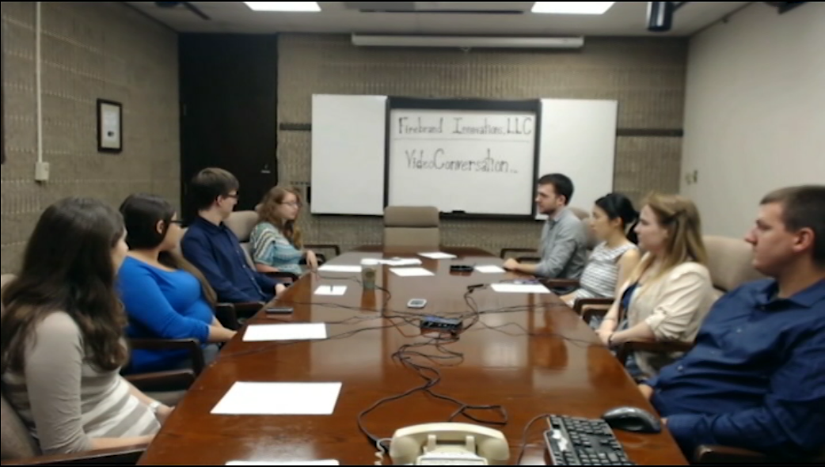

Caption: Full Room View with Centered Camera

VideoConversation’s first algorithm is Conversation Sensitive Zooming, which records how recently each person has spoken and frames the video to show all people who have spoken recently. This allows for conversations to be displayed naturally, enabling your team to naturally display non-verbal communication.

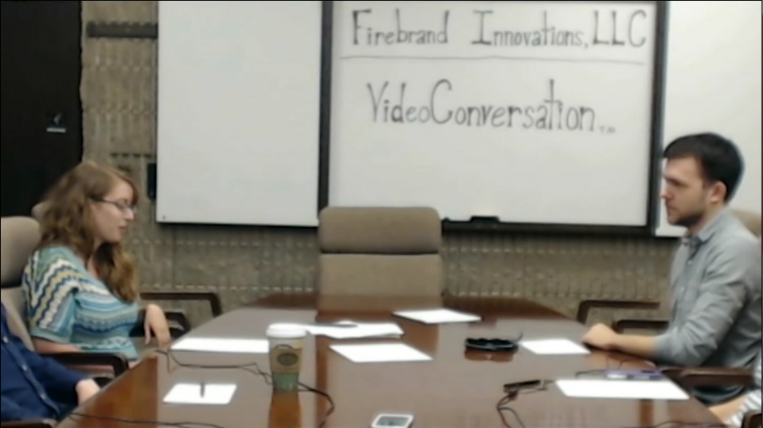

Caption: Conversation Sensitive Zooming

The second algorithm is Camera Selection which chooses which one out of the multiple available cameras to display. As can be seen in the picture below, the current conversation is shown best by the camera which is focused on the left side of the room. This improved perspective shows each of the participants in the conversation at a better angle, displaying facial movements in a better way.

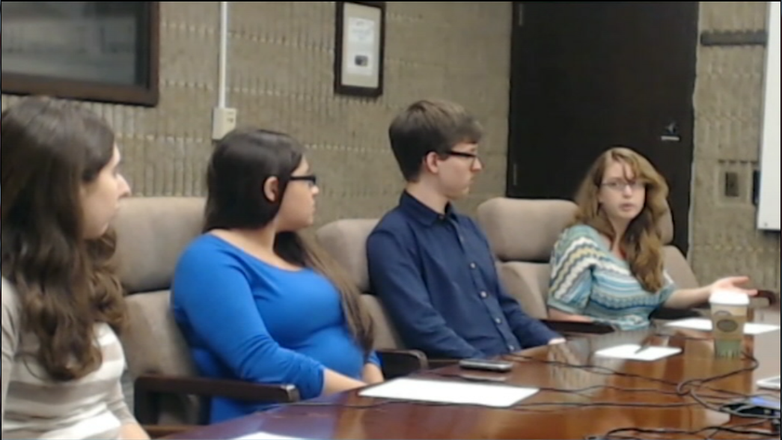

Caption: Camera Selection

*The Live Prototype*

Firebrand Innovations has developed a prototype system which implements the VideoConversation technology. This prototype can be set up and used in any standard conferencing room, just like the final system will be. For this prototype the speaker location is accomplished with individual speaker microphones. This is not the core technology however, and could be replaced by any other available methods.

Live demonstration

<http://www.youtube.com/watch?v=nP1VXaui0-M>

Behind the scenes

<http://www.youtube.com/watch?v=87v5jcJZBU0>

*The Target Market*

VideoConversation is designed to be used by teams of all kinds. Target customers are any company or organization who wants to upgrade a normal conferencing room to also be used for videoconferencing for a reasonable price. VideoConversation does not require any reconstruction of the room and does not prevent upgraded rooms from being used for normal off-line conferences.

*The Competitive Advantage*

Simple videoconferencing systems such as LifeSize’s Icon system do not provide the necessary automatic zoom for immersive group videoconferencing. The lack of automatic zoom results in a wide shot of all participants, hiding all the valuable non-verbal communication through facial expressions and body movement.

Polycom’s Eagle Eye Director does provide automatic zooming, but can only display conversations if participants are sitting directly next to each other. Our system can display conversations for any part of the room, including across the table as seen our demonstration video.

Cisco’s TelePresence TX9000 and 3200 Series systems are very effective but they are both prohibitively expensive and prevent the upgraded room from ever being used as a normal conference room. These factors prevent the systems from being bought by small to medium size companies as well as cost or space conscious large companies.

*Contact:*

Can make the email address a link that a user could click

If you would like to license this IP or hear more about VideoConversation please email contact@firebrandinnovations.com

*Copyright at bottom:*

Firebrand Innovations LLC 2013